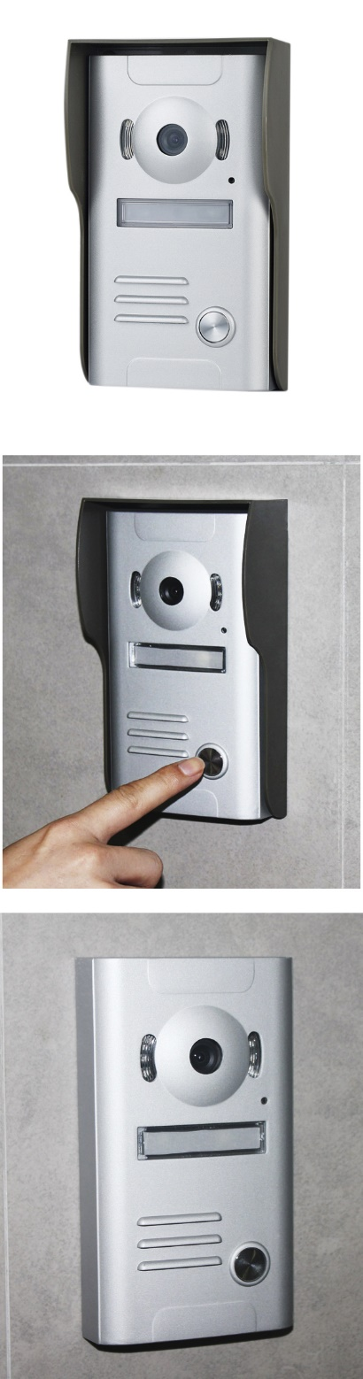**Product Features：**  
* IP56 waterproof outdoor unit.   
* Outdoor camera with rain shade can avoid direct sunshine.   
* Intercommunication is available between indoor unit and outdoor unit.  
* Damage-proof outdoor unit.  
* High definition camera, Night vision.   
* Hands-free intercommunication.   
* Monitoring the outdoor.   
* Brightness, Chroma and ring adjustable.   
* 8-chord melody rings for option.   
* DIY installation.

**Technique Parameter**Adapter input Voltage:AC100-240V 50Hz-60Hz Dual-Voltage.  
Adapter output Voltage、Current:DC15V 1500mA  
Talk time delay: 120S ±10%  
Monitor time delay: 40S ±10%  
Dissipation: stand by＜0.5W, Working ＜10W  
Working Temperature:-35℃～55℃  
Relative humidity: 10%-90 %( RH)

[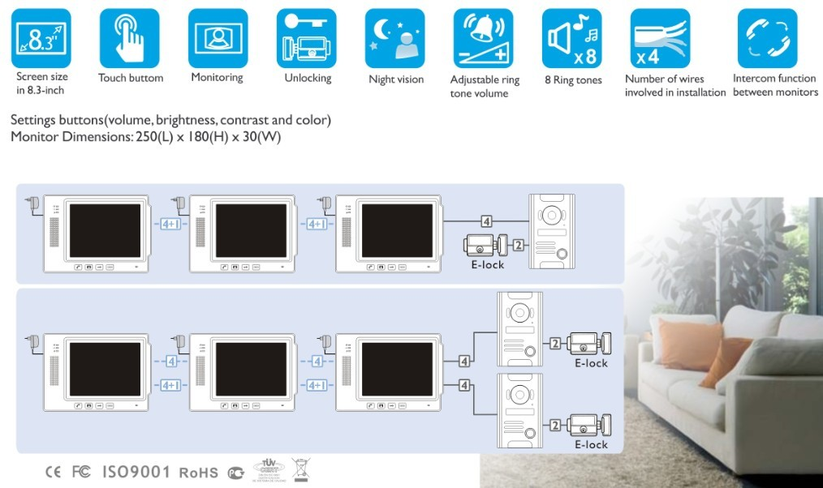](http://www.zhudele.com/uploads/140228/1_130829_1.jpg)

